Social Media Engagement and Productivity among High School Students
Andrew Futter
EDU 6330: Digital and Media Literacy
Dr. Jennifer Wojcik

Introduction

This curriculum unit is designed for 11th and 12th grade students and will explore basic social media concepts and the history of key moments in the media industry. Its intention is to be used for students who have a general interest in social media, want to explore more aspects of the industry, or want to pursue it further in college or in a career. This unit is specifically designed for students in the grades listed above because of their maturity in the classroom and to enhance their skills in the field before graduating. Each student will have needed to complete ninth-grade English and one United States history or government class prior to enrolling in this course. There are three lessons in this curriculum unit that focus on: determining authentic and fake news; learning laws and ethical uses of media; and learning to write for social media and proper posts. The lessons are designed to meet the requirements of specific framework from the International Society for Technology in Education and the Massachusetts Curriculum Framework standards. Each lesson has specific content that will engage students in class and demonstrate their knowledge of the subject through the use of worksheets, articles, videos and handouts. Each lesson will allow students to work in teams and individually to learn more about the specific content and enhance their knowledge in the field. Whether students are beginners or advanced users of social media, they will become more proficient users of technology, be able to identify trustworthy news sources, and learn the progression of the media industry throughout the 20th and 21st centuries.

Needs Analysis: Social Media Engagement and Productivity

Rationale

My learners will be students in a typical public high school setting. The high school is described as small and rural in Western Massachusetts, amounting to around 400 students in grades nine through 12. According to profile of the high school provided by the Massachusetts Department of Elementary and Secondary Education, white students make up roughly 87 percent of the school population, nearly five percent are Hispanic, and two percent are African American, while other races make up the rest. In the same report, it is reported that roughly 50 percent of the student population are economically disadvatnaged or have high needs. There are also 245 students in seventh and eighth grade that are included in these statistics.

The students will be learning a small and engaged classroom setting that deals with social media and communications. Some challenges that may arise with the implementation of this curriculum could be that students might not have social media accounts or might not want to create an account for the lessons. In this case, they may be interested in creating a fake account with classmates of similar ideals. As a result of half of the student population being economically disadvantaged and have high needs, it will be necessary for the school to provide technology equipment and textbooks to students for lessons during classes.

The main goal of this curriculum is to make students become productive and engaged members of society through the understanding of and use of social media in the classroom or during their own time. When students are accurately able to understand messages generated through social media, they can identify cultural codes that essentially make up a social system, as noted by Hobbs (Mihailidis & Thevenin, 2013, p. 4). Not only will productive social engagement improve citizenship and collaboration, but they also deconstruct media texts and injustices along the way (Mihailidis & Thevenin, 2013, p. 5). By the end of this course, students will have a “core understanding of media literacy as a collaborative and participatory movement that aims to empower individuals to have a voice and to use it” (Mihailidis & Thevenin, 2013, p. 7).

Grade Levels

The grade levels that will be enrolled in this curriculum will be in 11th and 12th grade.

Curriculum Areas

The learning areas of this curriculum unit will be tied into the English department and electives dealing with social media and society.

Suggested Curriculum Frameworks

The curriculum frameworks used in this unit are taken from the Massachusetts Curriculum Framework and ISTE Standards for Students. The ISTE Standards, are targeted toward students to assist them with becoming a learner, digital citizen, designer, communicator and thinker. The Massachusetts Curriculum Framework is split between the English Language Arts and Literacy standards and History and Social Science standards. For a full list of the frameworks, please refer to Appendix A.

Media Literacy Competencies
The media literacy competencies for this course will be in relation to what students learn in the real world using social media. They will be determining best practices for using social and how to use it to be a productive and engaged citizen of the world. They also will learn to determine what content on social media is from reputable sources and from fake sources. By practicing this, students will be able to learn the validity of news sources. In addition to media literacy competencies, students will also learn how to navigate popular social media tools such as Twitter and Facebook. As summarized by the National Association for Media Literacy Education (NAMLE), “the purpose of media literacy education is to help individuals of all ages to develop the habits of inquiry and skills of expression that they need to be critical thinkers, effective communicators, and active citizens in today’s world” (Scheibe & Rogow, 2012, p. 36).
Digital Tools
In this curriculum, students will have access to a laptop that is provided to them on behalf of the school system, unless they have one from home they would like to use. They also will have access to a smartphone device, which is provided by the school system. There will be limited numbers of laptops and smartphones available, so students will be sharing in the class. In addition to these devices, there will be specific software downloaded on each of the devices for teachers and students to track engagement and productivity. This will similar to analytics tools used by social media platforms.

Pedagogy/Theoretical Framework
With the purpose of this curriculum unit being for students to become productive and engaged members of society through the use of social media, it is fitting for the theoretical framework to focus on participatory media literacy. By using social media in the classroom, students can learn effective ways to create a message to their audience and using a public voice that is engaging for others. Digital and social media is a developing product in society today with more cultures and people adapting to products. However, there are some cultures and underprivileged populations that do not have access to resources. According to Scheibe and Rogow (2012), participatory digital culture is essential for each student developing higher-order thinking skills (p. 2). In some lessons in this unit, students will have the opportunity to learn how to write for social media, which will help students learn skills for the field. “Participatory culture is emerging as the culture absorbs and responds to the explosion of new media technologies that make it possible for average consumers to archive, annotate, appropriate, and recirculate media content in powerful new ways” (Jenkins et al, 2009, p. 8).
While students will learn practical tools to use social media, they will also learn to think critically about the content in the lessons. This is essential to have a stronger background about what they are learning, which is why critical media literacy is also a theoretical framework to be used in the unit. Students will learn from their teachers and with their peers how to effectively use social media in a classroom setting and apply that to the local, national and world communities. They will also be taught to recognize the difference between real and fake social media. If students are exposed to the so-called “fake news” in the world today, they will have distinguishing between what is right and wrong. As mentioned in Cheng, Hong and Szeto’s (2016) research, teachers guide the digital-native generation and also “face the issues of selecting the right knowledge for and finding the timely pedagogies in a changing educational context mediated by the Internet technologies” (p. 37). By constantly using social media in the classroom, students will have a better chance to learn technology and social media properly outside of their leisure and become productive and engaged citizens in society.

Lesson #1: Authentic vs. Fake News
Rationale
Students will be exposed to a number of social media posts and links to articles in those posts. Through examining the author, user and article, they will learn to find evidence of authentic social media. The articles will be varied from reputable news sources, writers, and others from fake accounts. The purpose of this lesson is to expose students to news articles online and determine their credibility. The lesson is designed to get students thinking about the world around them and how information is circulated online. Ultimately students will learn best practices and effective ways to identify authentic and fake social media.
Grade Levels
- Grades 11 and 12.
Curriculum Areas
- Social media, technology and English language arts.
Suggested Frameworks
Massachusetts Curriculum Framework: English Language Arts and Literacy
Grades 11-12 Reading Standards for Informational Text [RI]
5. Analyze and evaluate the effectiveness of the structure an author uses in an exposition or argument, including whether the structure makes points clear, coherent, convincing, and engaging.
ISTE Standards for Students
3a. Students plan and employ effective research strategies to locate information and other resources for their intellectual or creative pursuits.
3b. Students evaluate the accuracy, perspective, credibility and relevance of information, media data or other resources.
3d. Students build knowledge by actively exploring real-world issues and problems, developing ideas and theories and pursuing answers and solutions.
Learning Objectives
- Students will identify authentic and fake social media accounts, news, graphics and messages.
- Students will learn the importance of accurate messages to spread them and become engaged members of society.
Vocabulary
Social media, accuracy, fake, engagement and productivity.
Preparation and Prerequisites
- If students do not have a social media account, they will have to create a shared social media account on Twitter or Facebook to analyze content on accounts.
- If students have a social media account, they will be permitted to use their own accounts if they choose to.
- Students must complete 9th grade English in order to take this elective class.
Time Needed
- There will be a one-week introductory plan for this unit of the course meeting three times a week for the 70-minute class period. This will be followed by two weeks of material for the course. The specific lesson will occur during one 70-minute class period.
- After completing the introductory plan, students will be assigned to monitor various social media accounts and complete reports that will be shared with the teacher and classmates. This will occur throughout the unit.
Material and Equipment
- Personal laptop or cell phone.
- Laptops and cell phones provided by the school.
- Social media accounts on Twitter and Facebook.
General Step-by-Step Procedure
- Explain to the students the purpose of the lesson. Allow the students to have an open discussion about what they believe constitutes real or fake content. (5 minutes)
- Allow students to read the article from Harvard University on spotting fake news. In addition, provide handout to students to keep for reference (Appendix B). (5 minutes)
- Open discussion on how content on social media is spread and what can happen when misinformation is spread knowingly or unknowingly. (5 minutes)
- At this point students should already have created social media accounts on Facebook and Twitter. If not, allow them to create/log-in to social media accounts to analyze content. This will continue throughout the class term.
  - Students will be permitted to work in groups if they do not have a social media account or do not want to make their own.
- In small groups of three or four (or if they created social media accounts together), the students will explore any articles they can find on social media. Instruct them to take notes and answer questions from Harvard article and Appendix B. (15 minutes)
- Have an open discussion on findings from exploring social media. (10 minutes)
  - What did they find interesting on different social media platforms?
  - What accounts did they focus on, such as national news, local news, sports, etc.?
  - Were there any articles that looked suspicious? If so, have them provide examples.
- Allow students to break into original teams from social media activity. They will choose one or two stories from the article from Business Insider and do brief research online to find more about the story. They will share with the class information about the story. (10 minutes)
- To finish class, students will do further exploration on articles online and answer questions on newsworthiness from an activity by PBS Newshour (see Appendix C). (20 minutes)
  - Instruct students to write brief takeaways from articles and why they are relevant to each question.
  - If time runs over, students will share their findings during the next class period.
Assessment
Throughout the unit, students will be required to present their findings on a variety of social media accounts. At the end of the unit, students will do a final presentation on what they took away from the unit and provide examples of what they found. The presentations will be on what they learn about obvious authentic and fake accounts, as well as some that they cannot determine to be reputable sources. There will also be a time to brainstorm with students how to spread authentic news accounts and how to stay vigilant of fake news accounts.

Lesson #2: Laws and Ethical Use of Media
Rationale
Students will learn the ethics and laws behind social media use and digital media. Through examining the history of media laws and ethic, including court cases and current issues, students will be able to better understand how to use social media productively and effectively. The main objective behind this unit in the social media course is for students to better understand the laws, become better users of social media, and to know the consequences of breaking social media laws. By learning about specific court cases and its influence on media and social media, students will have a better understanding of right and wrong in the industry.
Grade Levels
- Grades 11 and 12.
Curriculum Areas
- Law, ethics, government, social media, technology, and English language arts.
Suggested Frameworks
Massachusetts Curriculum Framework: History and Social Science
GOV T4.4. Evaluate the benefits and disadvantages of new technologies in politics, including how they broaden the influence of media and public interest groups.
GOV T4.5. Analyze current research on the impact of media on civic discourse and the importance of an informed citizenry that determines the credibility of sources and claims and exercises other sound media literacy skills.
NML T1.3. Give examples of how a free press can provide competing information and views about government, policies, and politics.
NML T2.2.6,7. The combined influence of print, radio, and film as news media in the 1930s-1950s; and the impact of broadcast journalism on television in the 1950s-1990s, an the Internet and social media from the 1990s-21st century.
NML T3.2. Explain the conventions investigative journalists use and the steps they take in developing and checking the facts in news articles.
NML T3.5. Explain how becoming a discerning news consumer can change individual lives and have an impact on the integrity of a democratic system of government.
NML T4.1. Explain the importance of determining the sources of information on a website, potential biases, available evidence, and perspectives of other sources.
NML T4.2. Explain methods for evaluating information and opinion in print and online media.
NML T4.3. Analyze how assertion differs from verification, evidence differs from inference.
NML T4.4. Evaluate and deconstruct media from all mediums on a public policy issue at the local, state, or national level.
ISTE Standards for Students
2b. Students engage in positive, safe, legal and ethical behavior when using technology, including some interactions online or when using networked devices.
2c. Students demonstrate an understanding of and respect for the rights and obligations of using and sharing intellectual property.
2d. Students manage their personal data to maintain digital privacy and security and are aware of data-collection technology used to track their navigation online.
Learning Objectives
- Students will identify laws and ethical practices used in media and social media, and how to best use them.
- Upon identifying the laws and ethical practices, students will learn to become productive and engaged members of society when using social media.
- Students will understand how laws have evolved over time with the emergence and advancement of social and digital media.
Vocabulary
Social media, law and ethics.
Preparation and Prerequisites
- Students must complete 9th grade English in order to take this elective class.
- Students must complete a United States history or government course in order to take this elective class.
Time Needed
- This unit in the course will run for four weeks meeting four times a week for a 50-minute class period. The specific lesson will occur during two 50-minute class periods.
Material and Equipment
- Textbooks that will be provided by the school system.
- Notebooks and writing utensils provided by the students.
- Laptop provided by the school system.
General Step-by-Step Procedure
- At the beginning of class, the students will watch the TED Talk by Gerd Leonhard and briefly discuss it afterwards. Have them think about how it ties into media, social media, and digital law, and ethical practices. (25 minutes).
- Using the activity provided by PBS Newshour (see Appendix D), students will learn the definition of ethics and rules of journalism. Students will then have the chance to answer a series of questions (only first three) in small groups of three or four. (15 minutes)
- After the activity, students will have an open discussion with the entire class on their responses and compare actions taken for each scenario. (10 minutes).
- During the next class, students will work in pairs to analyze key court cases that are regarded as important in media law. Using the document in Appendix E, students will answer questions that will be turned into a small project at a later date. Students will only work on one court case. (30 minutes)
- The pairs of students will briefly share their findings as a summary to the rest of the class. This will be preliminary as the pairs may not have a full understanding of the court cases. (20 minutes).
Assessment
Throughout the unit students will do assignments that will be due for the next class period or ones in a few days to demonstrate their knowledge of the laws and ethics previously learned. Students will also have group projects in class to have collaborative learning opportunities to learn from peers and then present their findings to the class. Finally students will have three quizzes and a unit test administered and designed by the teacher to demonstrate their findings of law and ethics in social media.

Lesson #3: Social Media Writing
Rationale
Students will learn how to properly write content for social media that is short, concise and meaningful for the specific audience. They will analyze several examples of social media news and other sources that are short, concise and meaningful. Through this unit in the course, students will be able to learn from examples and further develop their writing for social media that is informative and accurate for a variety of audiences. This lesson will allow students to become better thinkers and understand what they are reading. This ultimately will allow them to write clear and concise messages not only on social media, but in other assignments in school.
Grade Levels
- Grades 11 and 12.
Curriculum Areas
- Social media, technology, journalism and English language arts.
Suggested Frameworks
Massachusetts Curriculum Framework: English Language Arts and Literacy
Grades 11-12 Reading Standards for Informational Text [RI]
2. Determine two or more central ideas of a text and analyze their development over the course of the text, including how they interact and build on one another to provide a complex analysis; provide an objective summary of a text.
6. Determine an author’s point of view or purpose in a text in which the rhetoric is particularly effective, analyzing how style and content contribute to the power, persuasiveness, or beauty of the text.
Grades 11-12 Writing Standards [W]
4. Produce clear and coherent writing in which the development, organization, and style are appropriate to task, purpose, and audience.
ISTE Standards for Students
6a. Students choose the appropriate platforms and tools for meeting the desired objectives of their creation or communication.
6c. Students communicate complex ideas clearly and effectively by creating or using a variety of digital objects such as visualizations, models or simulations.
6d. Students publish or present content that customizes the messages and medium for their intended audiences.
7a. Students use digital tools to connect with learners from a variety of backgrounds and cultures, engaging with them in ways that broaden mutual understanding and learning.
Learning Objectives
- Students will enhance their timely writing and reading skills that are beneficial not just for them, but for their audiences.
- Students will learn to write for social media, which consists of timely, accurate and concise messages and content.
Vocabulary
Social media, English language, concise, timely, accurate, engaging, journalism.
Preparation and Prerequisites
- Students must complete 9th grade English in order to take this elective class.
- This unit in the course is designed for students who are interested in journalism and enhancing their presence on social media.

Time Needed
- This unit will run for two weeks meeting four times a week in 50-minute class periods. The specific lesson will occur during one 50-minute class period and have similar activities throughout the two weeks.
Material and Equipment
- Personal laptop or cell phone.
- Laptops and cell phones provided by the school.
- Social media accounts on Twitter and Facebook.
General Step-by-Step Procedure
- At the beginning of class, students will watch a brief video highlighting tips to writing effective social media posts. (5 minutes)
- At this point students should already have created social media accounts on Facebook and Twitter. If not, allow them to create/log-in to social media accounts to analyze content. This will continue throughout the class term.
  - Students will be permitted to work in groups if they do not have a social media account or do not want to make their own.
- Review graphic of social networking statistics (see Appendix F) and allow students to express what stands out to them most. (5 minutes).
- Provide three short prompts (two or three paragraphs each) for students. Instruct them to read the prompts and write a brief summary of each on their social media platforms. This is for practicing meeting the required amount of characters on Twitter (280), which then can be posted to Facebook. (15 minutes)
  - Following this, students will share their findings with the class. (5 minutes)
    - Write down similarities and differences, what can improve, etc.
- Instruct students to pick a topic of their choice, but one that has been discussed in the news recently.
  - Sports, elections, healthcare, travel, international relations, etc.
- Once a topic has a been chosen, students will find three articles online using their school-issued laptops. They will read the articles and summarize them in no more than 280 characters, posting them from their social media accounts for their peers to see. Students must embed the articles in their tweets or Facebook posts. (20 minutes)
- In the next class, students will go to their social media accounts to view the tweets and embedded articles. They will work in teams to determine accuracy in writing and how it relates to the article.
  - The teacher will also have access to the accounts to view the students’ work.
Assessment
Students will complete a number of writing assignments during the unit to test their knowledge of social media writing and display their own writing skills. The primary method that their writing will be assessed is through the social media posts, which will also be followed by the teacher through an administrative account. There also will be quizzes to demonstrate writing ability and knowledge of reading as mentioned in the suggested frameworks for this unit. Additionally, a unit test will be administered at the end of the two-week unit, which is essentially a longer version of the quizzes that the students already have taken.

References
Gilbert, B. (2019, November 6). The 10 most-viewed fake-news stories on Facebook in 2019 were just revealed in a new report. Business Insider. Retrieved from https://www.businessinsider.com/most-viewed-fake-news-stories-shared-on-facebook- 2019-2019-11
International Federation of Library Associations and Institutions (2020). How to spot fake news. Retrieved from https://www.ifla.org/publications/node/11174
International Society for Technology in Education (2020). ISTE Standards. Retrieved from https://www.iste.org/standards
Jenkins, H., Clinton, K., Purushotma, R., Robison, A. J., & Weigel, M. (2009). Confronting the challenges of participatory culture: Media education for the 21st century. The John D. and Catherine T. MacArthur Foundation. Retrieved from https://www.macfound.org/media/article_pdfs/JENKINS_WHITE_PAPER.PDF
LiveTiles. (2016, July 13). 6 fun social media projects to assign in the classroom. Retrieved from https://www.livetiles.nyc/6-fun-social-media-projects-assign-classroom
Massachusetts Department of Elementary and Secondary Education. (2017). English language arts and literacy: Grades pre-kindergarten to 12. 1-196. Retrieved from http://www.doe.mass.edu/frameworks/ela/2017-06.pdf
Massachusetts Department of Elementary and Secondary Education. (2018). History and social science framework: Grades pre-kindergarten to 12. 1-217. Retrieved from http://www.doe.mass.edu/frameworks/hss/2018-12.pdf
Mihailidis, P. & Thevenin, B. (2013). Media literacy as a core competency for engaged citizenship in participatory democracy. American Behavioral Scientist. XX(X). 1-12.
Nagler, C. (2020). 4 tips for spotting a fake news story. Harvard Summer School. Retrieved from https://www.summer.harvard.edu/inside-summer/4-tips-spotting-fake-news-story
PBS Newshour Student Reporting Labs (n.d.). Lesson 1.1: What is newsworthy? Retrieved from https://studentreportinglabs.org/lesson-plans/lesson-1-1-what-is-newsworthy/
PBS Newshour Student Reporting Labs (n.d.). Lesson 1.3: Journalism Ethics. Retrieved from https://studentreportinglabs.org/lesson-plans/lesson-1-3-journalism-ethics/
Potter, J. [Five Minute Social Media – Jerry Potter]. (2017, December 14). 5 easy tips for writing social media posts [Video]. YouTube. Retrieved from https://www.youtube.com/watch?v=C9n71DKdRbw
Scheibe, C. & Rogow, F. (2012). The teacher’s guide to media literacy: Critical thinking in a multimedia world. Corwin: Thousand Oaks, CA.
Szeto, E., Cheng, A. Y., & Hong, J. (2015). Learning with social media: How do preservice teachers integrate YouTube and social media in teaching? The Asia-Pacific Education Researcher. 25(1). 35-44.
TEDx Talks. (2014, December 6). Digital ethics and the future of humans in a connected world | Gerd Leonhard | TEDxBrussels [Video]. YouTube. Retrieved from https://www.youtube.com/watch?v=bZn0IfOb61U

Appendix A
ISTE Standards for Students
2b. Students engage in positive, safe, legal and ethical behavior when using technology, including some interactions online or when using networked devices.
2c. Students demonstrate an understanding of and respect for the rights and obligations of using and sharing intellectual property.
2d. Students manage their personal data to maintain digital privacy and security and are aware of data-collection technology used to track their navigation online.
3a. Students plan and employ effective research strategies to locate information and other resources for their intellectual or creative pursuits.
3b. Students evaluate the accuracy, perspective, credibility and relevance of information, media data or other resources.
3d. Students build knowledge by actively exploring real-world issues and problems, developing ideas and theories and pursuing answers and solutions.
6a. Students choose the appropriate platforms and tools for meeting the desired objectives of their creation or communication.
6c. Students communicate complex ideas clearly and effectively by creating or using a variety of digital objects such as visualizations, models or simulations.
6d. Students publish or present content that customizes the messages and medium for their intended audiences.
7a. Students use digital tools to connect with learners from a variety of backgrounds and cultures, engaging with them in ways that broaden mutual understanding and learning.

Massachusetts Curriculum Framework: English Language Arts and Literacy
Grades 11-12 Writing Standards [W]
4. Produce clear and coherent writing in which the development, organization, and style are appropriate to task, purpose, and audience.
Grades 11-12 Reading Standards for Informational Text [RI]
2. Determine two or more central ideas of a text and analyze their development over the course of the text, including how they interact and build on one another to provide a complex analysis; provide an objective summary of a text.
5. Analyze and evaluate the effectiveness of the structure an author uses in an exposition or argument, including whether the structure makes points clear, coherent, convincing, and engaging.
6. Determine an author’s point of view or purpose in a text in which the rhetoric is particularly effective, analyzing how style and content contribute to the power, persuasiveness, or beauty of the text.
8. Delineate and evaluate the reasoning in seminal historical texts, including the application of constitutional principles and the use of legal reasoning and the premises, purposes, and arguments in works of public advocacy.
Massachusetts Curriculum Framework: History and Social Science
GOV T4.4. Evaluate the benefits and disadvantages of new technologies in politics, including how they broaden the influence of media and public interest groups.
GOV T4.5. Analyze current research on the impact of media on civic discourse and the importance of an informed citizenry that determines the credibility of sources and claims and exercises other sound media literacy skills.
NML T1.3. Give examples of how a free press can provide competing information and views about government, policies, and politics.
NML T2.2.6,7. The combined influence of print, radio, and film as news media in the 1930s-1950s; and the impact of broadcast journalism on television in the 1950s-1990s, an the Internet and social media from the 1990s-21st century.
NML T3.2. Explain the conventions investigative journalists use and the steps they take in developing and checking the facts in news articles.
NML T3.5. Explain how becoming a discerning news consumer can change individual lives and have an impact on the integrity of a democratic system of government.
NML T4.1. Explain the importance of determining the sources of information on a website, potential biases, available evidence, and perspectives of other sources.
NML T4.2. Explain methods for evaluating information and opinion in print and online media.
NML T4.3. Analyze how assertion differs from verification, evidence differs from inference.
NML T4.4. Evaluate and deconstruct media from all mediums on a public policy issue at the local, state, or national level.

Appendix B
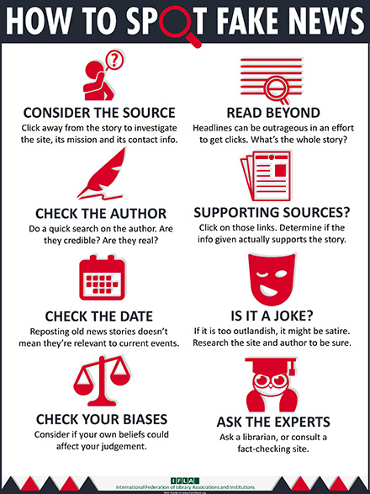

Appendix C
Appendix D
Appendix E
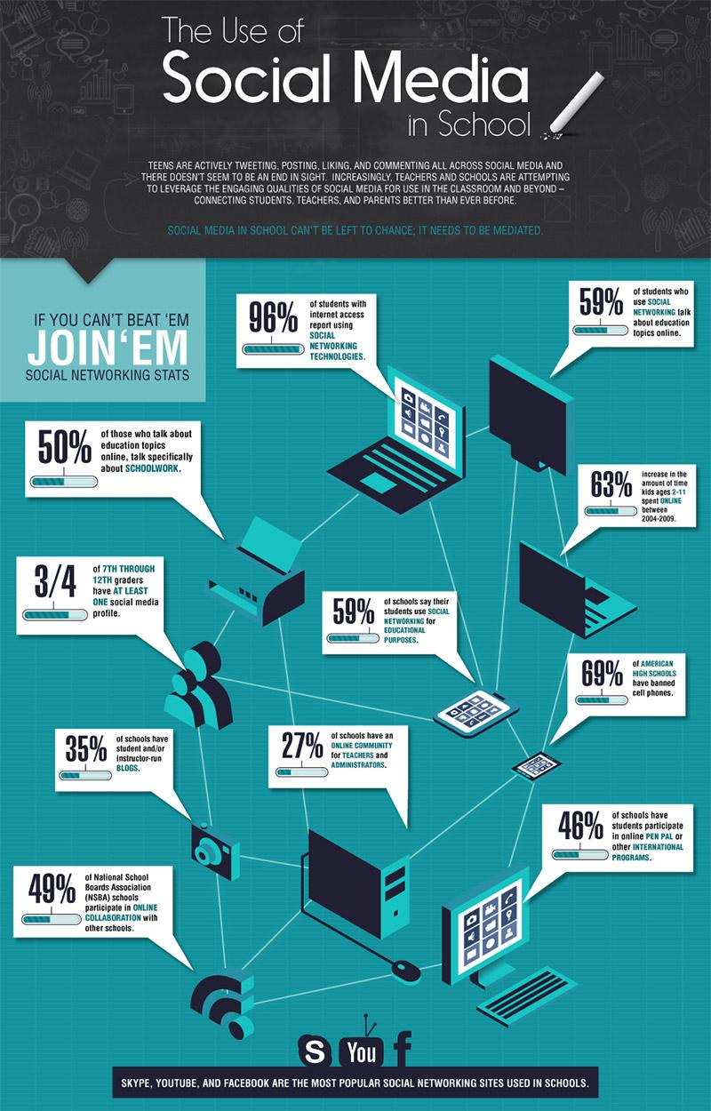
Appendix F

